

# PO1_DGC Calculator

**(CYRS)**

**Status**: **Released**

### **Document Status**

|  |  |  |  |
| --- | --- | --- | --- |
| **Version** | **Status** | **Author** | **Date** |
| V 1.0 | Draft | May Abdelsalam | 21/1/2020 |
| V 1.1 | Draft | Moemen Ahmed | 22/1/2020 |
| V1.2 | Draft | Moamen Ahmed | 26/1/2020 |
| V1.3 | Proposed | May Abdelsalam | 6/2/2020 |
| V1.4 | Proposed | May Abdelsalam | 6/2/2020 |

**History Table**

|  |  |  |  |
| --- | --- | --- | --- |
| **Version** | **Author** | **Date** | **Change** |
| 1.0 | May Abdelelsalam | 21/1/2020 | Initial creation |
| v1.1 | Moamen Ahmed | 22/1/2020 | Created index and improved formatting for CYRS document |
| v1.2 | Moamen Ahmed | 26/1/2020 | Updated Req PO1 DGC CYRS 006 v1.0 |
| V1.3 | May Abdelsalam | 6/2/2020 | Update CYRS to the comments in CYRS_Review and answers in SIQ sheet |
| V1.4 | May Abdelsalam | 6/2/2020 | Update the CYRS documents style and layout to match the rest of the documents in the project. |

## **Table of contents**

1. **Project Description.**
2. **System Requirements.**

## **Project Description**

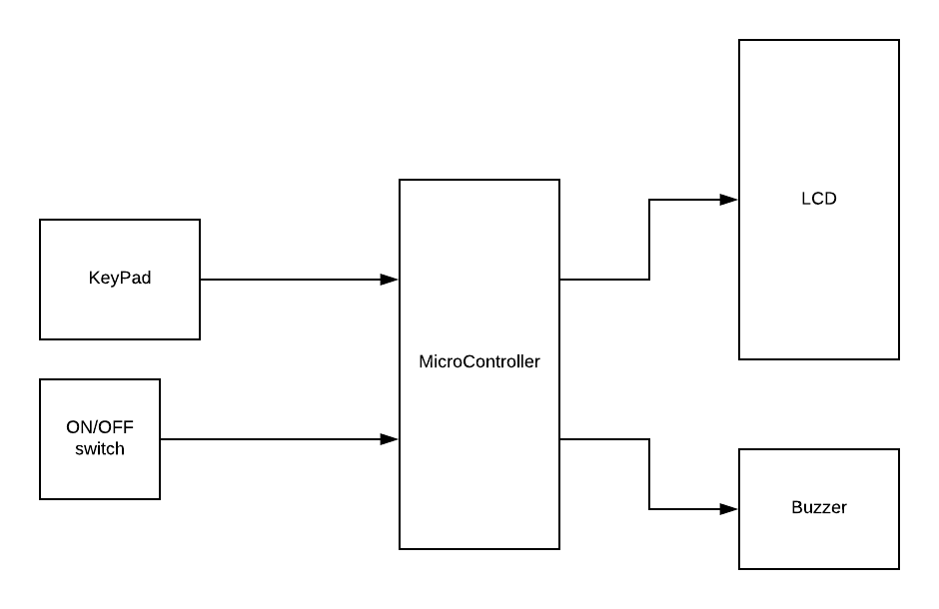

**System Requirements:**

* Req_PO1_DGC_CYRS_001_v1.1 Imp#HW

System has an ON/OFF button to control the power to the calculator.

If it’s pressed while the calculator is off it switches it on, and if pressed when it’s on it switches it off.

* Req_PO1_DGC_CYRS_002_v1.2 Imp#SW

A number from 0 to 9 or an operation (+, -, *, /, =) is assigned to each key on the keypad.

* Req_PO1_DGC_CYRS_003_v1.1 Imp#SW

System shall insure that the correct assigned number is displayed on the display whenever its corresponding key is pressed.

* Req_PO1_DGC_CYRS_004_v1.1 Imp#SW

If user tries to enter the division, multiplication, and addition operation at first before a number is entered the system shall display the following message “Please enter an operand first” in case of the subtraction operation it’s allowed.

* Req_PO1_DGC_CYRS_005_v1.0 Imp#SW

If a new operation is pressed while a one is already displayed, the new one will be applied and displayed instead of the old one.

* Req_PO1_DGC_CYRS_006_v1.1 Imp#SW

System shall display the result on the display when the assignment (=) key is pressed.

* Req_PO1_DGC_CYRS_007_v1.1 Imp#SW

System shall play a different tune for each button when pressed.

* Req_PO1_DGC_CYRS_008_v1.0 Imp#SW

System should handle negative numbers, a negative number entered by the user is the negative operation followed by a number.

The system should also handle negative results.

* Req_PO1_DGC_CYRS_009_v1.0 Imp#SW

System should insure that if the user tried to divide a number by zero this message will be displayed “Cannot divide by Zero”.

* Req_PO1_DGC_CYRS_010_v1.0 Imp#SW

System should handle fractions with a precision two numbers after floating point.

* Req_PO1_DGC_CYRS_011_v1.0 Imp#SW

The subtraction operation key can also be used as a negative sign.

* Req_PO1_DGC_CYRS_012_v1.0 Imp#SW

After performing a mathematical operation and pressing the assigning key the system shall wait for 10 seconds if no other operation is required the system shall turn off.

### **Reference Documents**

|  |  |  |  |
| --- | --- | --- | --- |
| **Reference Number** | **Document Name** | **Version** | **Status** |
| 1 | CRS | - | - |